Changing Default Settings

Change the Default Units
Navigate to Spotter Server Settings | 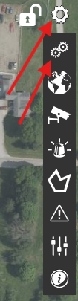
Go to Settings Tab | 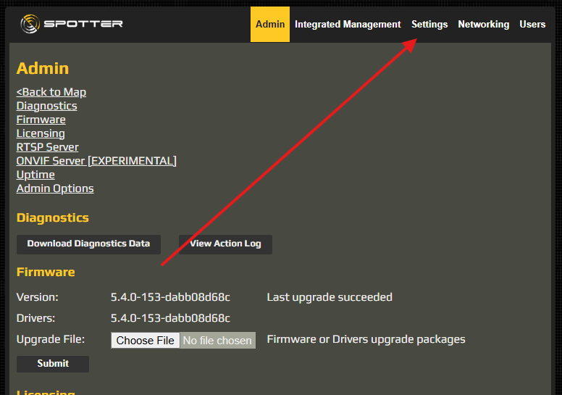
Set Speed to Meters per Second and Distance to Meters | 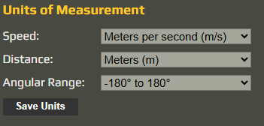

Creating Filters
Create filters by going to filter and clicking the + button
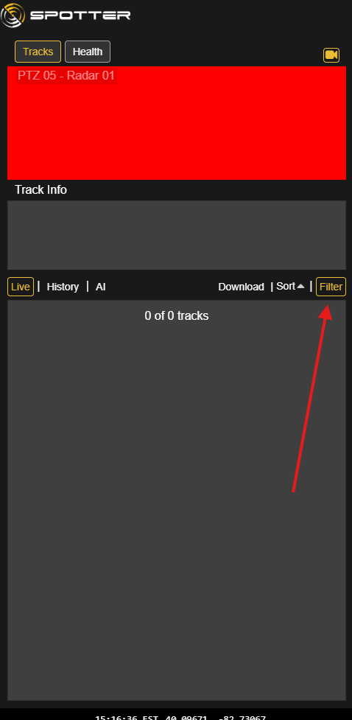 | 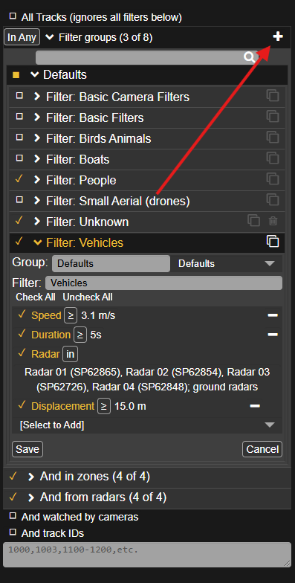

People Filter
Filter: People is a default, so you just need to modify the default People filter.  - Remove the upper bounds of speed  - Change duration to 5 seconds  - Select appropriate radars (usually can set to all ground radars)  - Replace distance with Displacement greater than or equal to 10m | 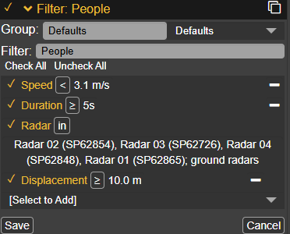

Unknown Filter
Filter: Unknown is not a default and needs to be created manually  - Set type = to Unknown with 0% confidence  - Select appropriate radars (usually can set to all ground radars) | 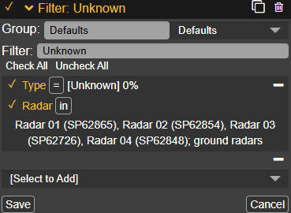

Vehicle Filter
Filter: Vehicles is a default, so you just need to modify the default Vehicles filter.  - Remove the lower bounds of speed  - Change duration to 5 seconds  - Select appropriate radars (usually can set to all ground radars)  - Replace distance with Displacement greater than or equal to 15m | 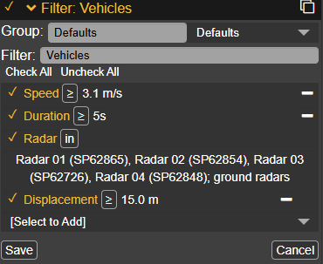

Creating Classifications

Classifications are a type of Action | 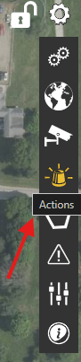
Create a new action by clicking the plus icon  Set the type to “Classification” | 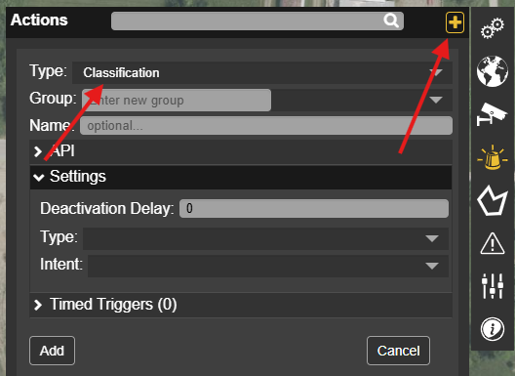

Probable People Classification
- Set the name to “Probable Person”  - Set the “Type” to Person  - Set the “Intent” to Unknown | 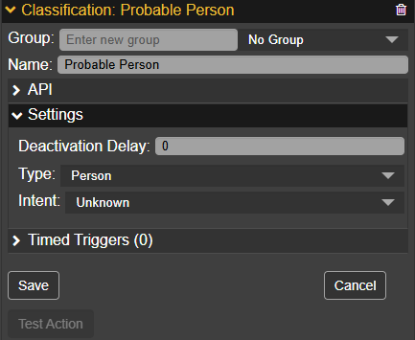

Probable Vehicle Classification
- Set the name to “Probable Vehicle”  - Set the “Type” to Vehicle  - Set the “Intent” to Unknown | 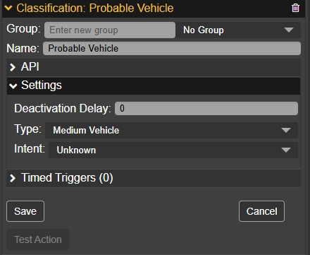

Setting Radar Sensitivity

Default

- Go to settings  - Go to Devices  - Select desired radar  - Go to “Sensitivity” | 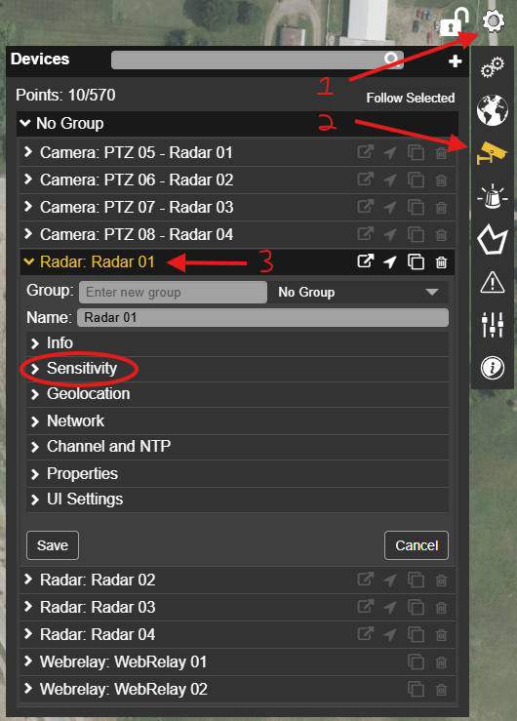
- Select the preset “Medium Wind”  - In some firmware, it’s just called “Medium” | 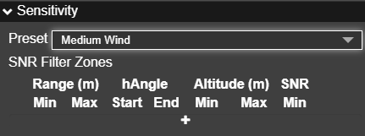

Adding Zone Classifications

Classification: Probable People
- Go to Settings  - Go to Zones  - Select desired Zone  - Go to “Actions” | 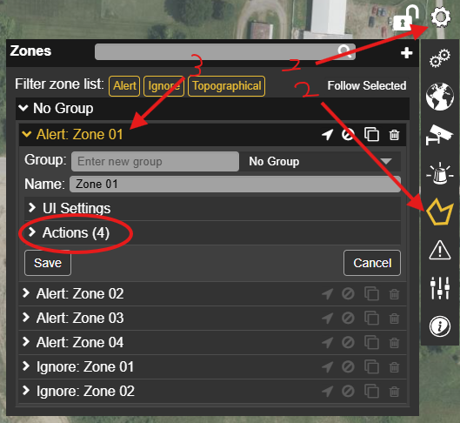
- Add a new action
- Set type to “classification”  - Set Action to your “Classification: Probable Person” you created  - Set Filter Group to People  - Click “Add” | 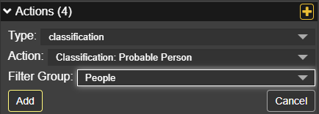

Classification: Probable Vehicle
- Go to Settings
- Go to Zones
- Select desired Zone
- Go to “Actions”
- Add a new action
- Set type to “classification”  - Set Action to your “Classification: Probable Vehicle” you created  - Set Filter Group to Vehicles  - Click “Add” | 